DTL PROJECT

Done by:

Arnav Deshpande - 101055

Aditya Dahihandekar - 101048

Rohan Gadgil - 101063

Aadam Gandhi - 101066

Samarth Dani - 101049

INDEX

|  |  |  |  |
| --- | --- | --- | --- |
| Sr no. | Title | Done by: | Pg no. |
| 1. | Part 3 – Identification of need | Aadam Gandhi |  |
| 2. | Part 4 – Concept generation | Rohan Gadgil |  |
| 3. | Part 5 – Generation and evaluation of alternative concepts | Samarth Dani |  |
| 4. | Part 6 – Product Architecture | Aditya & Arnav |  |
| 5. | Part 7 – Design for X | Rohan Gadgil |  |
| 6. | Part 8 – Modelling and prototyping | Aditya Dahihandekar |  |
| 7. | Part 9 – Detailed Design | Arnav Deshpande |  |

Identification of need:

* *Visually impaired people do not see the world as we do.*
* *Of the five human senses, the eyes are our most important sensory organs, helping us perceive up to 80% of the impressions and input we use to make sense of our surroundings.*
* Guide Dogs for the Blind Association provides assistance dogs for people with disability. Some dogs are trained specifically to help with certain tasks. They can be a great help to these people.
* With tape recorders **speech compressor** may be attached to it, and it causes the elimination of pauses between syllables and words, thus speeding up the rate at which the speaker speaks.

Gathering Information:

**Existing Products visually impaired people can use:**

* **Tape Recorder:** Many blind persons rely heavily on tape recorders. Either a cassette recorder or an open-reel recorder can be used in a variety of preferences of the blind employee.
* **Talking Computer Terminal**: A talking terminal is just what one would expect. It speaks the words that appear on the screen of a standard print terminal.* The synthesized speech of current talking terminals is clear enough for most people to understand immediately upon hearing it..
* **Lechal:** Using the technology of touch, Lechal has reinvented the way the visually impaired people navigate. The sole of Lechal shoes will be your new guide and you can bid a goodbye to the distracting audio instructions from your phone to navigate around.

Design and analysis of survey instrument technical literature:

* **Tape Recorder:** Many blind persons rely heavily on tape recorders. Either a cassette recorder or an open-reel recorder can be used in a variety of ways depending on the needs, assignments, and preferences of the blind employee. Large amounts of information can be rerecorded on tape rapidly and less expensively than the same information can be converted into Braille. Often blind employees can get volunteers to do some of this recording or another reader can record it when it is convenient for the blind person to be doing something else. Some reference materials can recorded onto tape and tone indexed. Some tape recorders have a variable speed control, so that the listener can speed up the tape and read the material more rapidly than it is recorded. Thus, tape recorders may be a valuable tool to blind persons who need to deal with printed materials, although other blind persons will use them very little, if at all.
* **Talking Computer Terminal:** The talking terminal must have some memory and a keyboard. It is generally attached to a print terminal in the system. It is up to the operator of the talking terminal to be knowledgeable about the print screen's formatting so that he or she will understand the full significance of what is said by the talking terminal. These terminals can be interfaced with a number of basic computer systems and the manufacturers can tell you what they are designed to interface with. The disadvantages of the talking terminal are its lack of portability and its lack of formatting. Advantages are speed in retrieving information and lack of need for substantial training by the user. Any blind person can learn to use a talking terminal quickly.
* **Lechal*:***Using the technology of touch, Lechal has reinvented the way the visually impaired people navigate. The sole of Lechal shoes will be your new guide and you can bid a goodbye to the distracting audio instructions from your phone to navigate around. Their insoles connect to the Lechal app via bluetooth which helps the wearer to use it as a navigation tool. Gentle vibratory responses will alert you when you need to turn. A buzz in the left shoe will indicate to take a left and a buzz in the right shoe means to turn in that direction. If you need to turn around, both feet with vibrate at once. It even works offline!

For more information about such products below links are referred:

1.<https://www.letsenvision.com/blog/products-designed-for-the-visually-impaired>

2. <https://www.nfb.org/sites/www.nfb.org/files/images/nfb/publications/fr/fr5/issue1/f050113.html>

**SVISION**

**Practical 4: Concept Generation**

After several discussions, proposal and elimination of ideas, we created the final model of SVISION.

The following points describe outcomes of the discussions throughout the modelling of final design of our product:

1. When we first decided to go with this product, we thought of using high frequency sound waves to predict nearby obstacles. We were also going to include extra features which would display information alongside to what the wearer sees. It was also proposed that it would support wireless technologies like Bluetooth, Wi-Fi and GPS.
2. The Additional features like information display, and external wireless connectivity would only add to the cost of the device and also wasn’t really very crucial and unnecessary for device functioning.
3. We continued with the high frequency sound waves proposition i.e echolocation - very similar to how bats see.
4. For output of the device it was first decided that we use tiny speakers attached on the goggles near the ears. The speakers would beep as the wearer approached an obstacle.
5. Then we also thought that we would add cameras or scanners so that books or text could be scanned and audio would be given as output.
6. Point no.4 was then discarded due to realization of the fact that most of the blind people also have some hearing disabilities, also continuous beeping may cause headaches for the user, point no.5 was only fancy and not really necessary so it was also discarded.
7. So, the device output was now touch stimulus. For this a wearable band was introduced Which would be linked to the goggles and would vibrate according to signals given by the goggles.
8. By now most of the functioning and prototype of the model was clear. Only a few additional features were introduced which would highly improve the user interface and also refine functioning of the device.
9. This included another change that was replacing a single band by two wearable bands in two hands so that position of obstacle would be more precisely declared to the user making the experience for the user much easier.
10. Another improvement was inclusion of a proximity sensor which would be attached to the sensor bands to deal with the few drawbacks of echolocation which includes non-detection of very close objects and very fast-moving objects. This inclusion refined the functionality of our device.
11. We realized that the sonar equipment (which we planned to fit in the ‘temples of earpiece’) was increasing the weight of the goggles. To deal with this problem we came up with attaching rubber foam nose pads.

GENERATION AND EVALUATION OF ALTERNATIVE CONCEPTS

* “Even when someone is losing their sight, they still have a good brain that’s trying to understand and pick up clues from object, if given enough input.”
* Wearable technology is becoming one of the most exciting parts of the technology sector, inspiring designers to come up with new invention and attracting investors eager to pour cash into potential money-spinning ideas.
* The optical design will require the integration of high spatial resolution micro-displays with low light loss optical see-through retro-reflective surfaces.
* Additionally, free-form optic enables optimization of field of view, resolution, depth of field and the minimization of image field distortion.
* The utilization of free form optics design methodology enables the use of off-axis, non-rotationally symmetric geometries that can enable custom, stylistic design.
* One of the first things that needs to be addressed is the size and weight of the glasses. The smart goggles are very light weighted and it is easy to handle.
* “sVision” initially its price is around75 ,000 rupees but has recently reduced the cost to around 50-55k rupees due to modifications and enhancements to the product, which has reduced a financial burden from the user.

DTL REPORT

Part 6

PRODUCT ARCHITECHTURE:

* sVision is a semi-modular type of product.
* Both the glasses and hand wearables are separate, and perform individual functions. If any one of them incur damage, they can individually be fixed.
  + This is the characteristic of a modular product.
* However, they are still connected together by LAN. The obstacle recording is performed by the spectacles while the pulse emission is performed by the hand wearables.
  + Proximity sensing is done by the hand wearables.
    - This brings in the aspect of an integrated product.
  + Integration is also seen in the syncing of the two hand-wearables.
  + The connectivity by LAN eliminates the requirement of using two sensors separately on hand-wearables and glasses.
* Since the neither characteristic is completely profound, we would term this as a semi-modular product.

EMBODIMENT DESIGN:

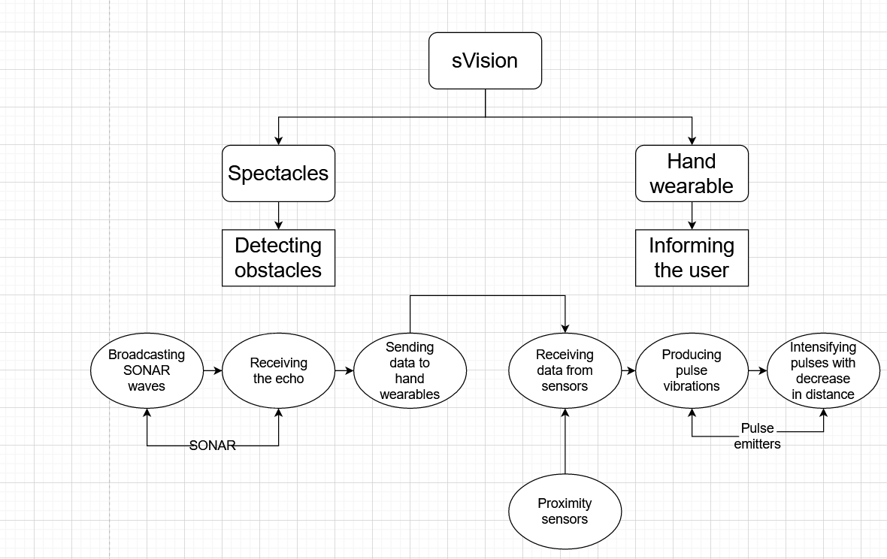

INDUSTRIAL DESIGN

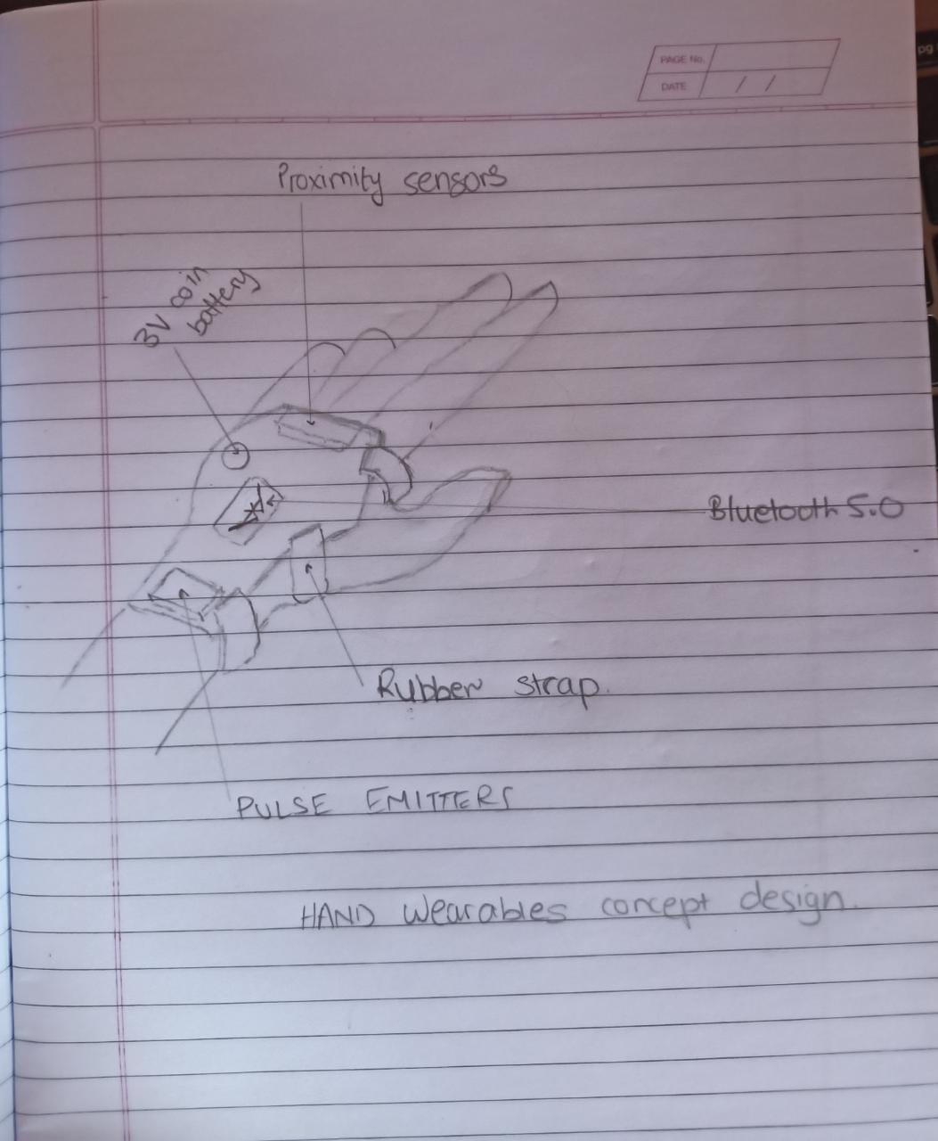

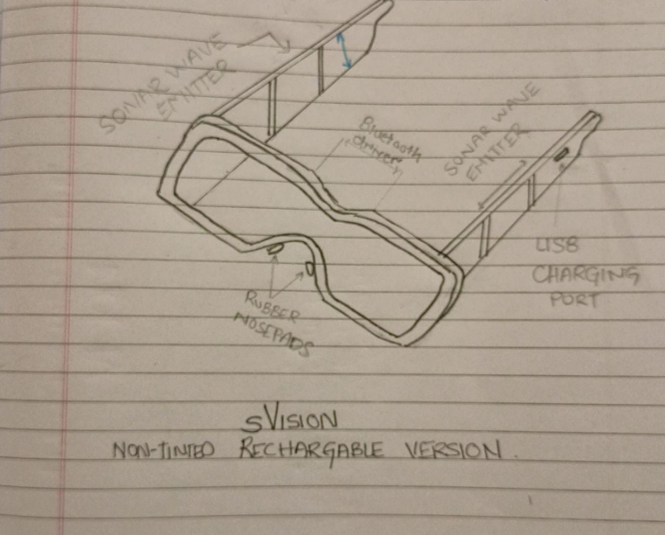

Hand wearables rough sketch

Spectacles rough sketch

* The sketches displayed above are representations of how we thought of building the models first.
* There are a few inconsistencies, like the placement of the Bluetooth syncing device and the feature of the USB charging port.
* These problems are dealt with further on.

**DESIGN DESCRIPTION:**

1. Spectacles
   1. Ultrasound device split into two parts to fit the arms of the spectacle.
   2. Syncing device is connected at the bridge of the spectacle.
   3. To handle the increased weight, we have nose pads made of rubber foam.
2. Hand-wearables
   1. Two hand-wearables, both synced to the glasses and also inter-synced.
   2. Ergonomic and comfortable to wear. Will not cause intrusion in handling of objects.
   3. The user interaction is basic and easy to understand. The product is a 70:30 mix of being technology and user driven.

**COMMERCIAL SPECIFICATIONS:**

1. Spectacles
   1. Sonar equipment used will have a sufficiently large range to detect even the furthest of obstacles.
   2. Powered by an Arduino chipset.
   3. Uses cushioning of rubber nose pads.
   4. Available in rechargeable battery mode
   5. Bluetooth used for efficient and rapid data transfer.
   6. Available in tinted, semi-tinted and non-tinted varieties.
2. Hand-wearables
   1. The hand wearables come in pairs. They are inter-synced to avoid confusion between direction of incoming object.
   2. Proximity sensors for nearby object detection.
   3. Powered by replaceable coin batteries.
   4. Have pulse vibration emitters that give signals as object is being approached.
   5. Provide grip to the hands to grasp anything, like a walking stick, with ease.

**TECHNICAL SPECIFICATIONS**

1. Spectacles
   1. Range of sonar equipment = 100m.
   2. Rechargeable battery life = 12h
   3. Bluetooth 5.0. used for data transfer.
      1. As compared to 4.2, 5.0 has 4 times the range, 2 times the speed and 8 times the capacity of the broadcasted message.
      2. It functions at speeds up to 2 MBPS.
   4. Links for different equipment used:
      1. Rubber-foam nose pads: -https://www.amazon.in/GMS-Self-Adhesive-Count-Black/dp/B013P7SMBI
      2. Rubber-foam nose pads alt: -https://www.amazon.in/Gejoy-Adhesive-Nosepads-Non-Slip-Eyeglass/dp/B07K811ZTZ
      3. Sonar equipment :- <https://www.amazon.in/Docooler-Fishfinder-Transducer-Electronic-Equipment/dp/B01LY9K0X1>
2. Hand Wearables
   1. Proximity sensors detection range up to 4.5m
   2. Powered by 3V rechargeable coin cells.
   3. Bluetooth 5.0. used for inter-syncing between hand wearables and for data transfer with spectacles.
   4. Pulse vibrations increase in intensity as object approaches nearby.
      1. Pulse emitters link: <https://www.directindustry.com/prod/precision-microdrives/product-39252-466981.html>
      2. https://boutique.semageek.com/en/241-mini-motor-vibrator.html

**DTL**

**SVISION**

**Experiment-7**

**HUMAN FACTORS DESIGN:**

Certain features of SVISION smart goggles which are included to consider the human factors are:-

1. Its simple design which includes only a goggle and two hand gloves highly increase the ease of use and accessibility.
2. For giving inputs to the user, initially we thought of giving sound signals by speakers which would be fixed near the ears. We realized that long use of this device would cause irritation and headaches. Considering this human pacification factor, we replaced these speakers with touch stimulating wearable band.
3. Instead of keeping a single wearable band we included two wearable bands which would help in giving a better idea of where the obstacle is located, thus improving human interface.
4. Due to increase in weight of goggles due to sonar equipment we added nose rubber foam pads to deal with this issue.

Page Break

**LIFE CYCLE DESIGN:**

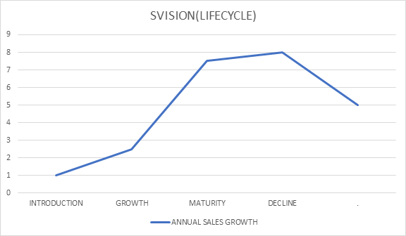

Currently our product is in the introduction stage and there is no similar product in the market. In the first stage the product would first see some increase in sales. Several developments would be made as we get reviews from customers. As the product becomes popular in the market there will be a large increase in the number of sales. Then slowly the product will mature and increase in sales will stabilize. This would take about 10-15 years after which new products will be launched by and will slowly replace our product leading it to the decline phase.

**DESIGN FOR SUSTAINABILITY:**

1. The parts do not need continuous replacement and last long.
2. Rechargeable coin batteries which can be replaced easily.
3. Most of the parts are replaceable so that one doesn’t have to spend heavily.
4. Replaceable signal interpreter on wrist bands.
5. Replaceable glass head with syncing device.
6. Expendable goggle handles with sonar equipment.
7. Easily wipeable glasses for cleaning goggles.

DTL Part – 8:

**MODELLING AND PROTOTYPING**

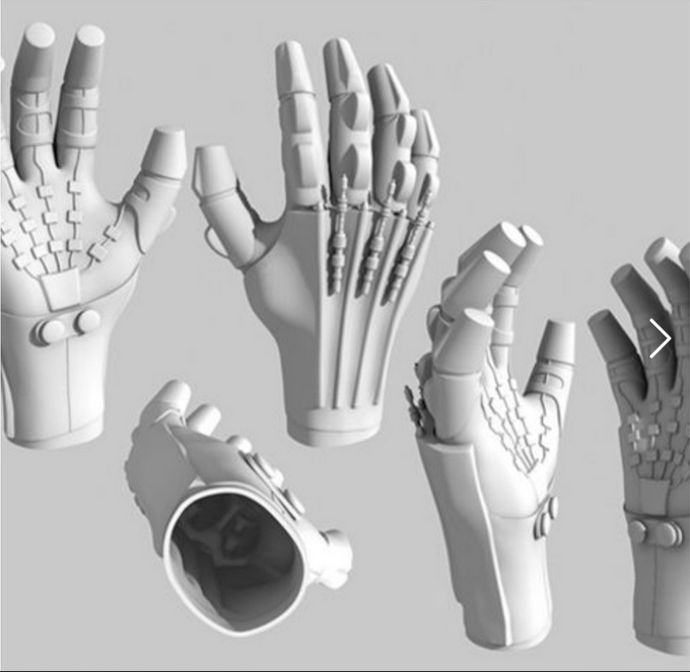

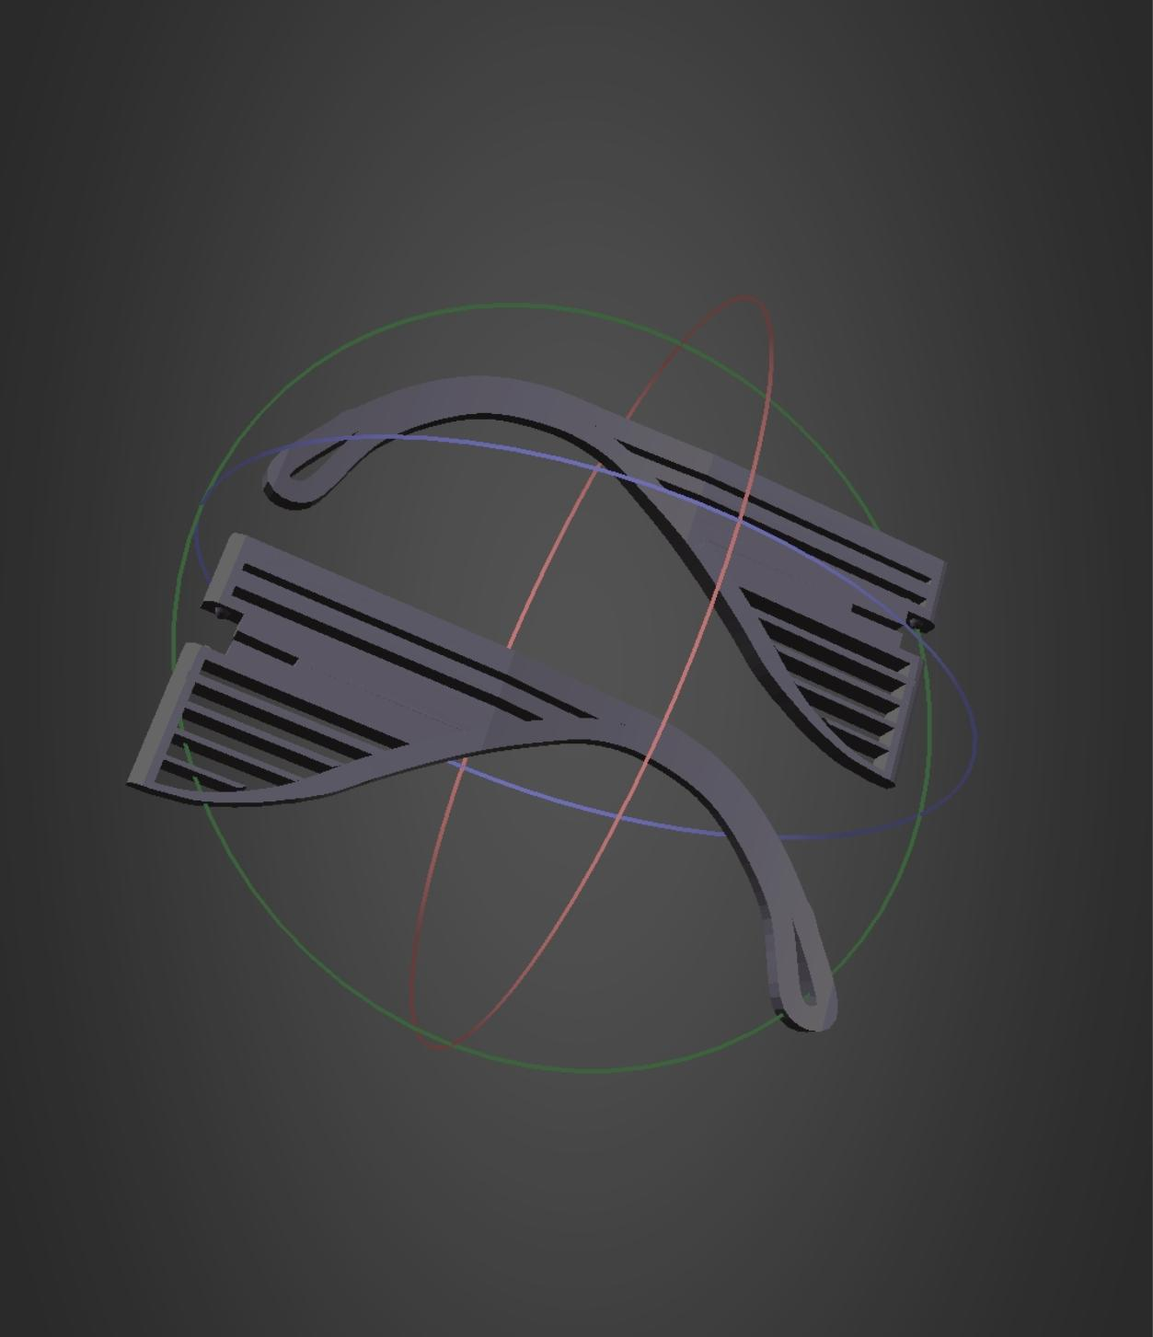

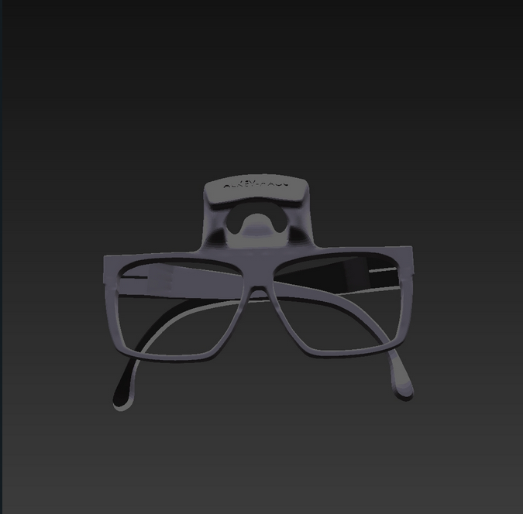

DTL Part – 9

**DETAILED DESIGN**

